***273/1***

***Geography***

***Paper 1***

***2 ½ hours***

**RESOURCEFULMOCKS 2019**

**UGANDA CERTIFICATE OF EDUCATION**

Uganda Certificate of Education

GEOGRAPHY

**PAPER 1**

2 Hours 30 Minutes

**Instructions to Candidates**

This paper consists of parts **I** and **II**

Part **I** and section **A** of part **II** are compulsory

Answer only **one** question from section **B** of part **II**

Answers to **all** questions **must** be written in the answer sheets provided

Any additional question(s) answered will **not** be marked

**PART I**

**OBJECTIVE – TYPE QUESTIONS (30 MARKS)**

There are **30** compulsory questions. Each question carries **one** mark.

1. Population distribution in the Miombo woodlands has mainly been influenced by
2. insecurity
3. unreliable rainfall
4. pests and diseases
5. remoteness of the area
6. The major problem facing cottage industries in East Africa is
7. inadequate capital
8. rural – urban migration
9. inadequate power supply
10. limited market
11. A Campbell stokes recorder at a weather station is used to record the amount of
12. pressure
13. temperature
14. sunshine
15. humidity
16. Which of the following features along the shores of Lake Victoria are a result of wave erosion
17. Cliffs and Stacks
18. Beaches and Arches
19. Stumps and Estuaries
20. Caves and Spits
21. Cross border trade among the East African countries is mainly limited by ;
22. high taxes
23. production similar goods
24. political instability
25. poor transport network
26. The U-shaped valleys in the senile stage of the river profile are mainly as a result of
27. lateral erosion
28. siltation
29. vertical erosion
30. river floods
31. Game sanctuaries in East Africa were established to
32. control poaching
33. reduce overstocking
34. carry out research on wildlife
35. protect endangered animals
36. Which of the following minerals in East Africa is mined using the dredging method?
37. Tin
38. Coal
39. Copper
40. Soda Ash
41. Rapid population growth rate in Uganda is mainly a result of
42. high fertility
43. improved medical care
44. improved nutritional levels
45. increased immigration
46. Which of the following rocks is fire formed?
47. Limestone
48. Shale
49. Pumice
50. Marble
51. Which of the following is a non - renewable energy source?
52. Geothermal
53. Solar
54. Oil
55. Biomass
56. Majanji fish landing site is found on which of the following Lakes
57. Albert
58. Kyoga
59. Victoria
60. Edward
61. Trees in the semi- arid areas of East Africa have small thorny leaves in order to allow the plant to
62. grow in poor sandy soils
63. withstand strong winds
64. keep cool during the day
65. reduce moisture loss
66. Thegradual increase in the overall temperaturesof the earth’s atmosphere is known as
67. Temperature Inversion
68. Climate change
69. Lapse rate
70. Global warming
71. Hot springs and geysers are potential site for generation of which of the following sources of energy
72. geothermal
73. hydro electricity
74. solar
75. thermal
76. Greenhouses are mainly used for commercial growing of flowers in East Africa because they
77. stabilize flower production
78. are pest and disease free
79. have controlled atmospheric conditions
80. easy flower harvesting
81. The dominant vegetation on the slopes of Mt. Kilimanjaro that is found below 1500 meters above sea level is
82. tropical rainforest
83. savannah grassland
84. heath and moorland
85. bamboo
86. Which of the following tea growing areas in East Africa is greatly affected by the problem of weather vagaries?
87. Kericho
88. Kasaku
89. Kyamuhunga
90. Liwala
91. The landform that separates two cirques in a glaciated highland is called
92. Arête
93. Pyramidal peak
94. Glacial trough
95. Hanging valley
96. Mining of uranium in Mirama Hills in the south coast of Mombasa has been limited mainly by the
97. Poor quality ores
98. Remoteness of the area
99. Scattered deposits
100. Inadequate skilled labour
101. The major challenge affecting the development of Port Bell on Lake Victoria is
102. Small hinterland
103. Inadequate port facilities
104. It is congested
105. collapse of the rail line
106. Which of the following is the main problem resulting from the establishment of cement processing industries in East Africa
107. competition for land
108. air pollution
109. rural – urban migration
110. exhaustion of raw materials
111. Wetlands in Uganda are being protected mainly because they
112. are potential fishing grounds
113. provide building materials
114. are potential grazing areas
115. recharge underground water sources
116. Which of the following is the most effectivemeasure ofcontrolling indiscriminate fishing on Uganda’s water bodies?
117. Sensitization of fishermen
118. Enforcing use of recommended fishing nets
119. Establishment of Beach Management Units
120. Introduction of modern fishing gear
121. Mass wasting on the Mount Elgon slopes is mainly caused by
122. heavy rainfall
123. earthquakes
124. deforestation along slopes
125. quarrying along slopes
126. Annual precipitation between 750mm - 1000mm is described as
127. low
128. very wet
129. moderate
130. wet
131. The renewed erosive activity by a river along its course is referred to as
132. rejuvenation
133. siltation
134. meander
135. capture
136. The major problem facingmarket gardening in East Africa is
137. shortage of skilled labour
138. poor land tenure system
139. inadequate refrigeration facilities
140. limited market
141. Steam jets on the inner walls of the caldera on Mt. Longonot are an indicator that the mountain is
142. extinct
143. active
144. violent
145. dormant
146. The distribution of road transport routes in East Africa has greatly been influenced by
147. drainage features
148. natural vegetation
149. relief
150. soils

**PART II**

**MAPWORK, PHOTOGRAPH INTERPRETATION, FIELDWORK AND EAST AFRICA**

Answer **four** questions from part **II**, including questions **1, 2** and **3** which are compulsory

**SECTION A**

1. **COMPULSORY QUESTION: MAPWORK (20 MARKS**)

Answer **all** parts of this question.

Study the map extract 1:50,000 **(UGANDA) LAKE NAKIVALI** and answer the questions that follow

1. state the grid reference of:
2. the dispensary South East of Kashojo (01 mark)
3. tank west of Kasumba (01 mark)
4. Identify the
5. **physical** feature at grid reference 727123 (01 mark)
6. **man made** feature at grid reference 694094 (01 mark)
7. (i) giving reason for your answer, state the general direction of flow of River Kogango (01 marks)

(ii)determine the vertical interval used on the map extract

(02 marks)

1. Draw a cross section of the area from grid reference 680010 to grid reference 730040 on it mark and name:
2. Dry weather road
3. footpath
4. woodland vegetation
5. any two rivers (06 marks)

1. (i) Describe the relief of the area shown on the map extract

(03 marks)

(ii) Explain the factors which have influenced settlement in the area shown on the map extract (04 marks)

2. **PHOTOGRAPH INTERPRETATION (COMPULSORY) (15 MARKS)**

Answer **all** parts of this question

Study the photograph provided below and answerthe questions that follow:

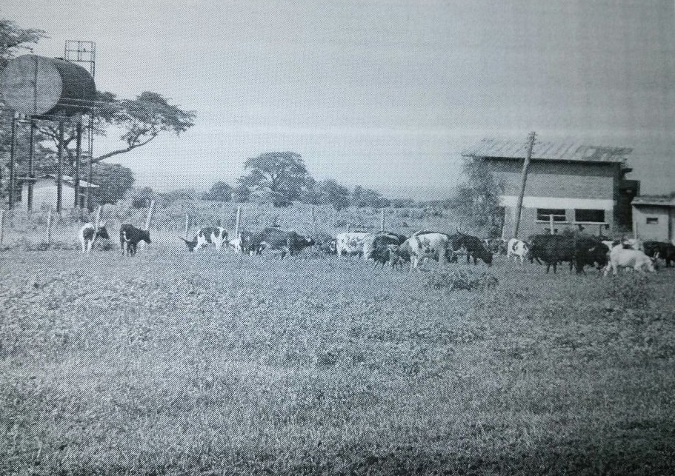

1. Giving reason for your answer, state the type of photograph provided above (01 mark)
2. Identify the economic activity taking place in the middle ground of the photograph. (01 mark)
3. (i)Describe the conditions that have favoured the economic activity identified in (b) above (05 marks)

(ii) Explain the importance of the economic activity to the people living in the area (06 marks)

1. Giving reasons for your answer, suggest an area in East Africa where the photograph could have been taken (02 marks)

3. **COMPULSORY QUESTION: FIELDWORK (15 MARKS)**

Answer **all** parts of this question

For any **one** fieldwork study you have conducted either as a group or an individual:

1. (i) state the topic of study (01 marks)

(ii) Outline the objectives of the study (02 marks)

1. Draw a cross section of the area studied and on it mark and name
2. Relief features
3. Landuseactivities (05 marks)
4. Explain the relationship between relief and landuse activities in the area studied (04 marks)
5. Outline the challenges you faced when conducting the fieldwork (03 marks)

**SECTION B: EAST AFRICA**

Attempt ***only one*** Question from this section. Each question carries (***20 marks)***

4. Study the map of East Africa provided and answer the questions that

follow:

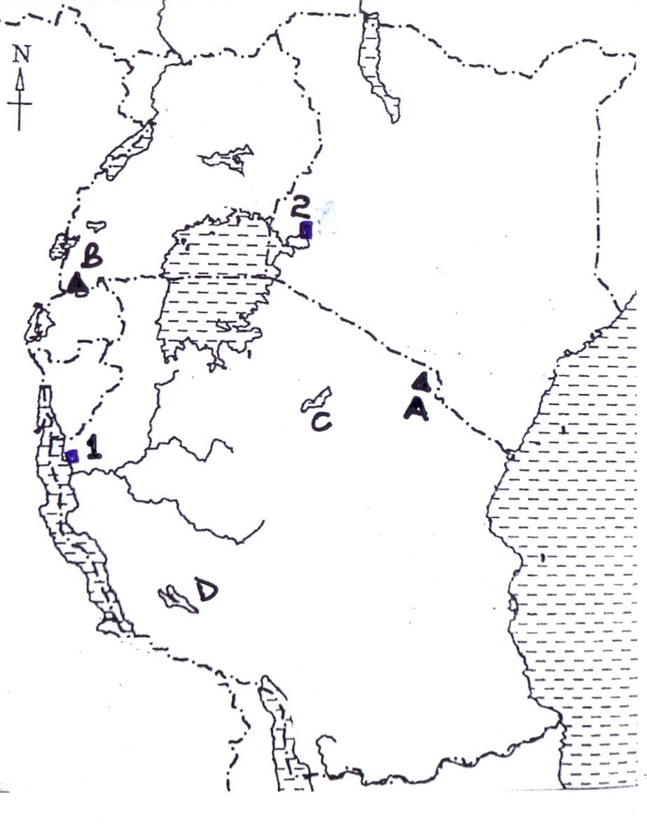

(a) Name the:

(i) Composite cones marked A and B

(ii) Graben Lakes marked C and D

(iii) Ports marked 1 and 2 (06 marks)

(b) Describe the processes which were responsible for the formation of composite cones in East Africa (05 marks)

(c) State the influence of mountains on the climate of East Africa

(05 marks)

(d) Outline the problems faced by the people living in the mountain regions of East Africa (04 marks)

5. Study table 1; below showing Uganda’s total population in millions (1969 - 2014) and answer the questions that follow

Table 1: Uganda’s total population (‘000,000) 1969 – 2014

|  |  |
| --- | --- |
| *Year* | *Population (‘000,000)* |
| 1969 | 9.5 |
| 1980 | 12.6 |
| 1991 | 16.7 |
| 2002 | 24.2 |
| 2014 | 34.8 |

*Adapted: UBOS; Population census report 2014*

1. Draw a line graph to represent the information given in the table

(06 mark)

1. (i) Calculate the percentage change in Uganda’s population between 1969 and 2014 (02 marks)

(ii) State the factors which have led to the population change in (b) (i) above (04 mark)

1. Explain the problems which have resulted from the population change identified in (b) (i) on the physical environment (05 marks)
2. Outline the measures being taken to combat the problems of high population growth in East Africa (03 marks)

6. Draw a sketch map of East Africa and on it mark and name:

(a) (i) Rivers:Athi and Pangani (02 marks)

(ii) Towns:Tororo and Dar-es-Salaam (02 marks)

1. hydro-electricity power stations:Kindaruma, Hale and Kidatu

(03 marks)

(b) Describe the factors that led to the location of any one hydro-electricity station named in (a) (iii) above (05 marks)

(c) Explain the contributions of the power and energy sector in East Africa (04 marks)

(d) Outline the steps being taken to promote the power and energy sector in East Africa (04 marks)

7. (a) (i) Differentiate between Natural forests and Plantation forests

(02 marks) (ii) Name any **two**

Planted forests

Natural forests

in Uganda (04 marks)

(b) Describe the conditions that have favoured the establishment of plantation forests in East Africa (04 marks)

(c) Explain the causes of natural forest cover destruction in East Africa (06 marks)

(d)Outline the effects of natural forest cover destruction in East Africa . (04 marks)

***END***